**Durham HK Mask Assembly Instructions**

Laser cut mask kit for COVID-19 readiness

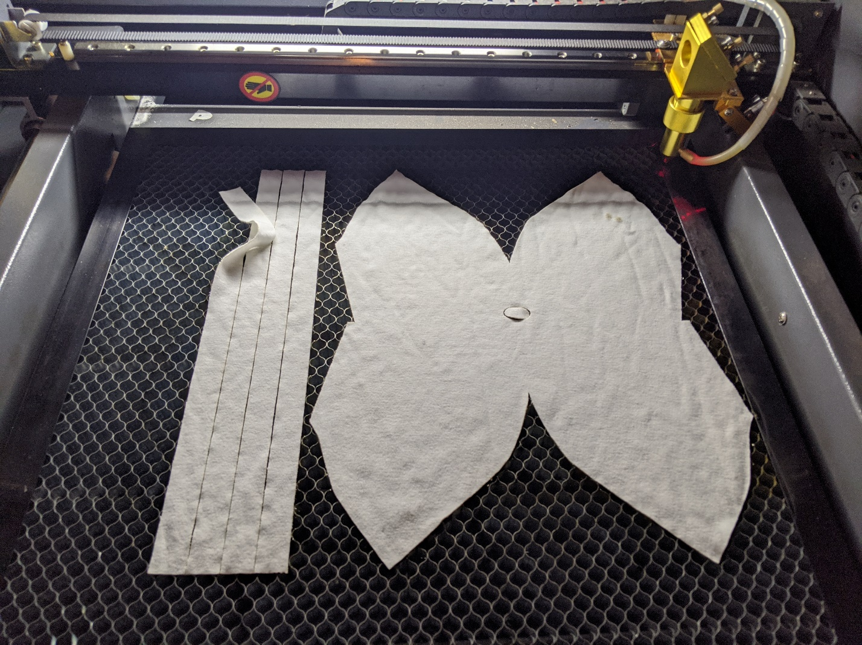

To make a mask, you’ll need a Durham HK Mask kit and a sewing machine. This mask is designed to support a replaceable filter between the 2 layers of the mask. Each mask kit consists of 4 straps and one foldable mask. A sample mask will be included with the supplies as an example.

Once you have completed a set of masks, please arrange return of the completed masks to the kit provider for distribution.

1. Attach the 4 ties to the locations seen in this photo. Use a zig-zag stitch if your sewing machine is capable. This photo shows the inner side of the mask.

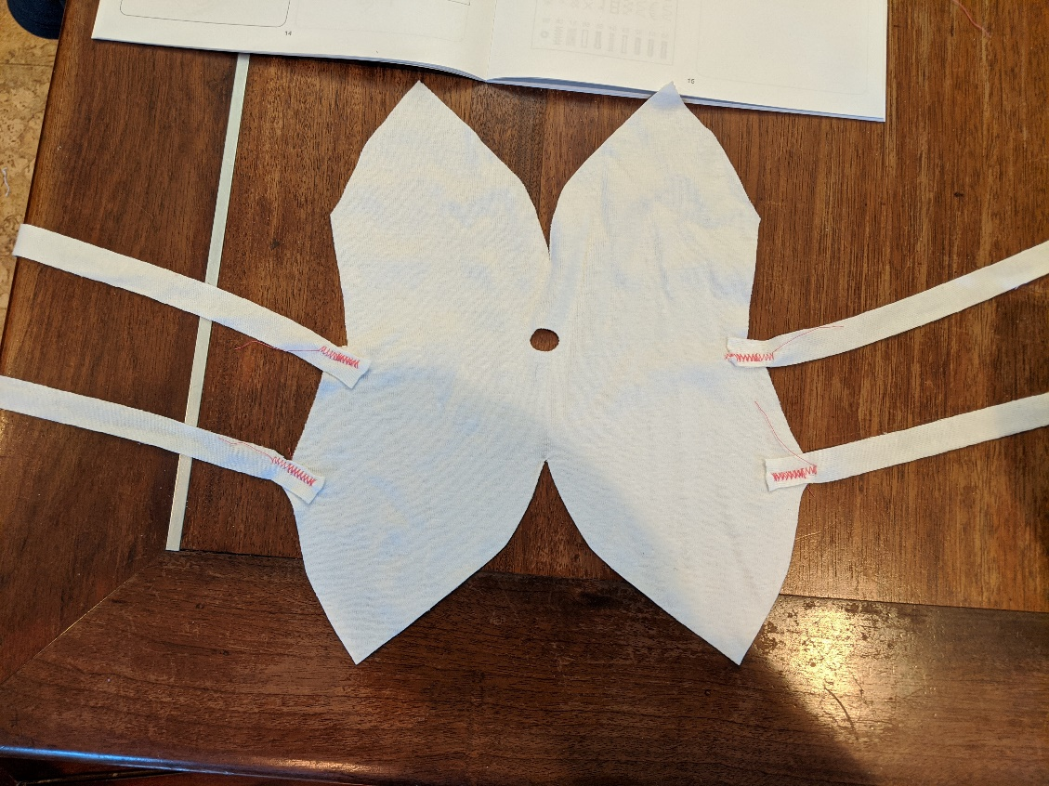

1. Flip the mask over. Stitch the outer chin curve using a straight stitch. The outer part of the mask should show a visible seam along the chin.

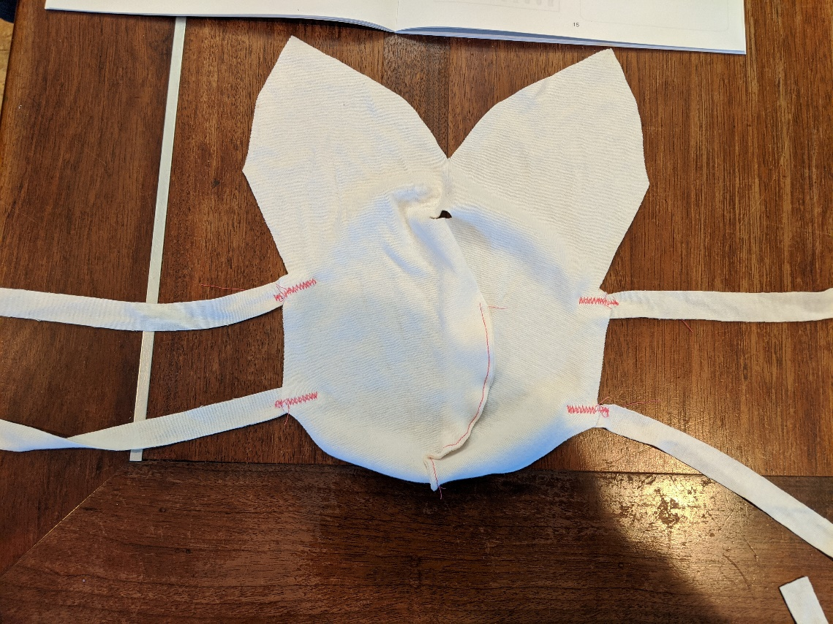

1. Stitch the inner chin curve so that the stitch is hidden once the mask is folded (no photo).
2. Fold the mask in and use 2 short stiches to connect the bottom halves together. This will form an open pocket between the 2 layers of the mask. This pocket is for a disposable air filter.

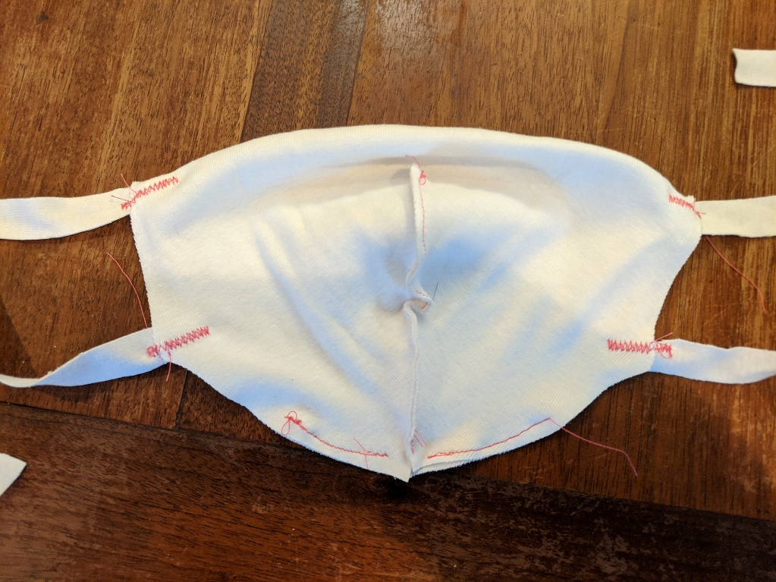

1. Make a short stitch under the nose support hole. This stitch will hold the removeable metal nose support strip.

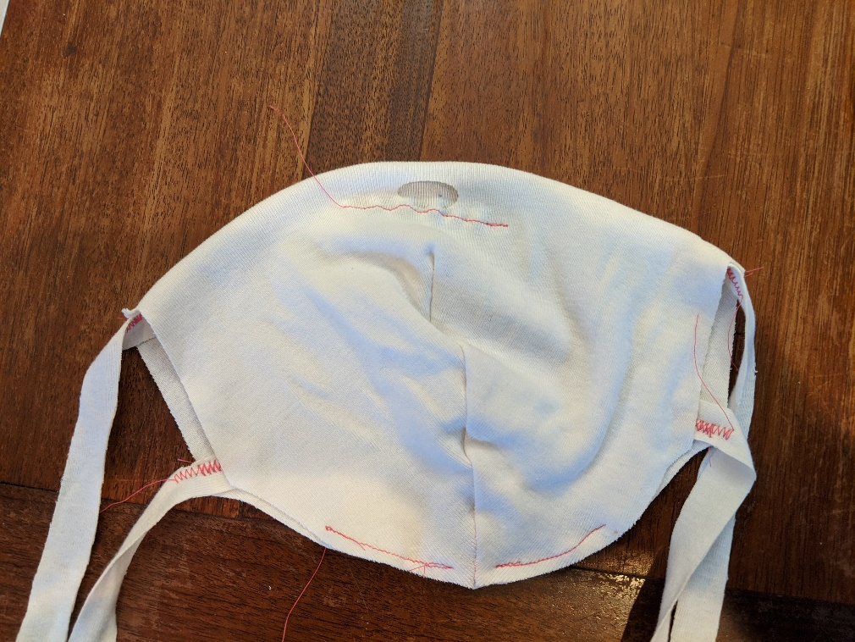

1. Trim any excess loose thread to complete the mask. Thanks for your efforts!